**Course:** ENSF 337 – Fall 2020

**Lab #:** Lab 4

**Instructor:** M. Moussavi

**Student Name:** Quentin Jennings

**Lab Section:** B03

**Submission Date:** 2020-10-12

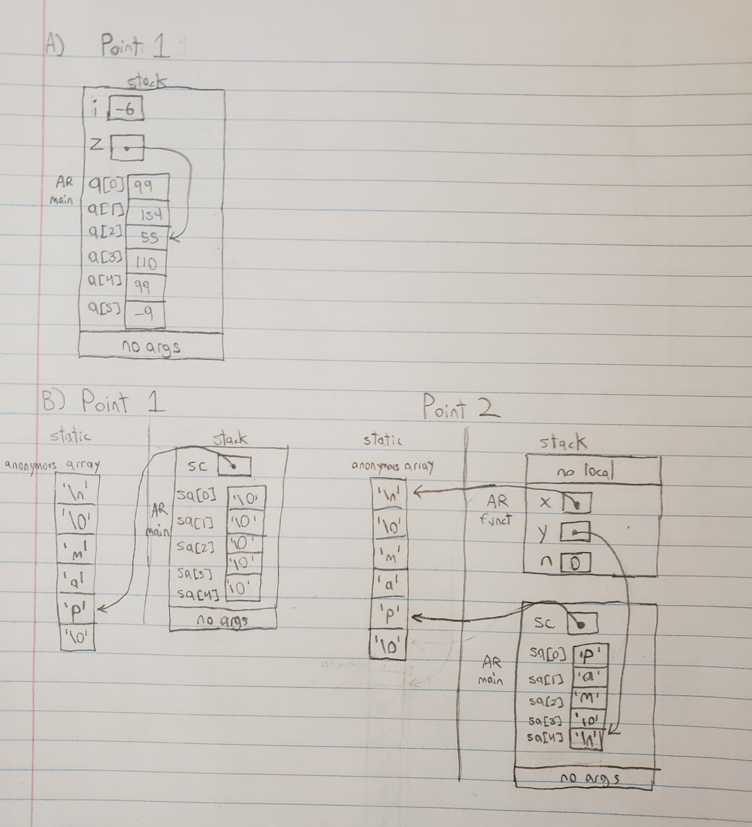**Exercise A and B:**

**Exercise C Output:**

Array a has 5 elements and macro ELEMENTS returns 5

Array b has 20 elements and macro ELEMENTS returns 20

**Exercise D Output:**

TESTING strlen FUNCTION ...

Expected to display: my_string length is 0.

my_string length is 0.

Expected to display: my_string size is 100 bytes.

my_string size is 100 bytes.

Expected to display: my_string contains banana.

my_string contains banana

Expected to display: my_string length is 6.

my_string length is 6.

Expected to display: my_string contains "".

my_string contains:""

Expected to display: my_string length is 0.

my_string length is 0.

Expected to display: my_string size is still 100 bytes.

my_string size is still 100 bytes.

TESTING strncat FUNCTION ...

Expected to display: my_string contains "tic"

my_string contains "tic"

Expected to display: my_string length is 3.

my_string length is 3.

Expected to display: my_string contains "tic-tac"

my_string contains:"tic-tac"

Expected to display: my_string contains "tic-tac-toe"

my_string contains:"tic-tac-toe"

Expected to display: my_string has 11 characters.

my_string has 11 characters.

Using strcmp - C library function:

Expected to display: "ABCD" is less than "ABCDE"

"ABCD" is less than "ABCDE"

TESTING strcmp FUNCTION ...

"ABCD" is less than "ABND" ... strcmp returns -11

"ABCD" is equal "ABCD" ... strcmp returns 0

"ABCD" is less than "ABCd" ... strcmp returns -32

"Orange" is greater than "Apple" ... strcmp returns

**Exercise E Output:**

Enter a real number or press Ctrl-D to quit: 23.4

Your real number value is: 23.400000

Enter a real number or press Ctrl-D to quit: .56

Your real number value is: 0.560000

Enter a real number or press Ctrl-D to quit: -.23

Your real number value is: -0.230000

Enter a real number or press Ctrl-D to quit: -0.45

Your real number value is: -0.450000

Enter a real number or press Ctrl-D to quit: -0.0000067

Your real number value is: -0.000007

Enter a real number or press Ctrl-D to quit: 564469999

Your real number value is: 564469999.000000

Enter a real number or press Ctrl-D to quit: +8773469

Your real number value is: 8773469.000000

Enter a real number or press Ctrl-D to quit: +.5

Your real number value is: 0.500000

Enter a real number or press Ctrl-D to quit: